**Assignment -4**

|  |  |
| --- | --- |
| Assignment Date | 09-November-2022 |
| Student Name | ANBUSELVAN S |
| Student Roll Number | 611619205008 |
| Maximum Marks | 2 Marks |

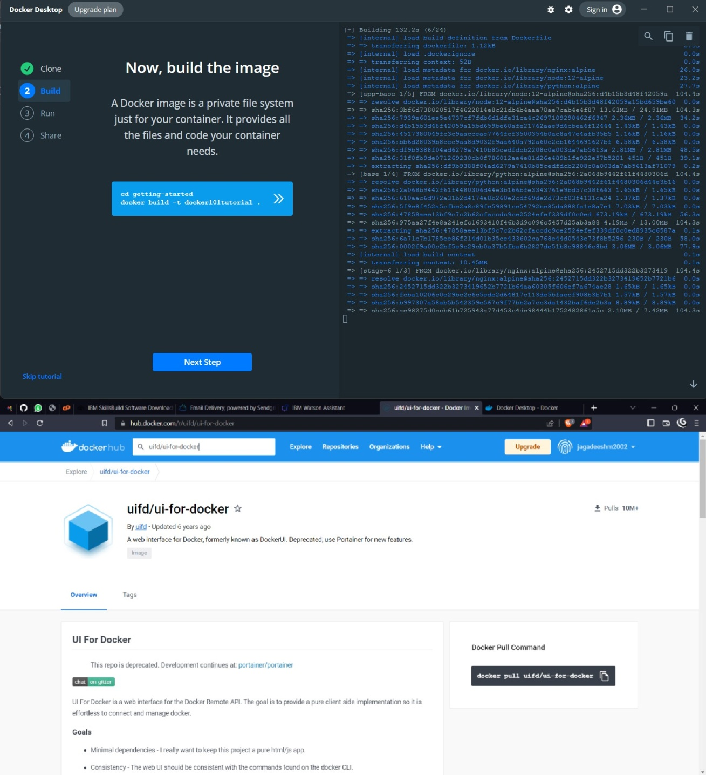

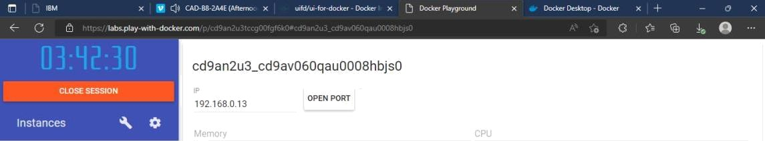



UI For Docker

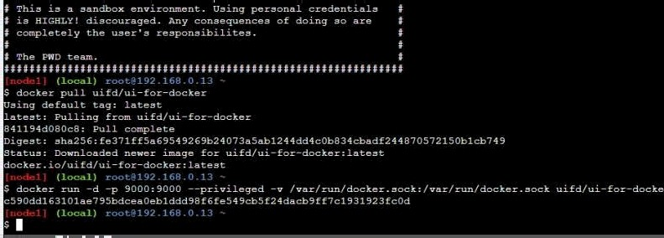

ssh [ip172-18-0-4-cd9an2u3tccg00tgt6k0@direct.labs.play-](mailto:ip172-18-0-4-cd9an2u3tccg00tgt6k0@direct.labs.play-) *C*





I For Docker

The UI for Docker container engine



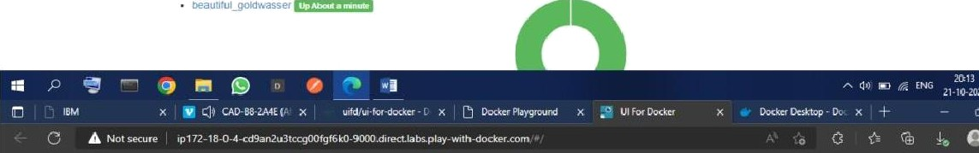Running Containers Status

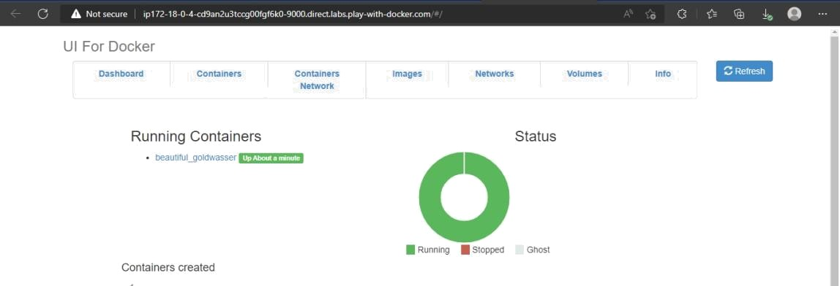

Images creaied

